## Water Baptism

Water represents identification with Christ in His substitutionary spiritual death on the Cross for our sins. Romans 6:3-5 is not speaking of water baptism, but Baptism of the Holy Spirit which is symbolized by water baptism.

"Or do you not know that all of us who have been baptized into Christ Jesus have been baptized into His death? Therefore we have been buried with Him through baptism into death, so that as Christ was raised from the dead through the glory of the Father, so we too might walk in newness of life. For if we have become united with Him in the likeness of His death, certainly we shall also be in the likeness of His resurrection," (Romans 6:3-5, NASB)

Believers have a real identification with Christ - in His death called Retroactive Positional Truth and in His resurrection called Current Positional Truth. Water baptism is a ritual baptism. The water is symbolic of the person and work of the Lord Jesus Christ and the believer being baptized is identified with the water.

When you go under the water you recognize that you have already been saved by an act of faith belief in Christ’s substitutionary spiritual death on the Cross where He paid the penalty for all of your sins. Christ on the Cross also rejected human good.

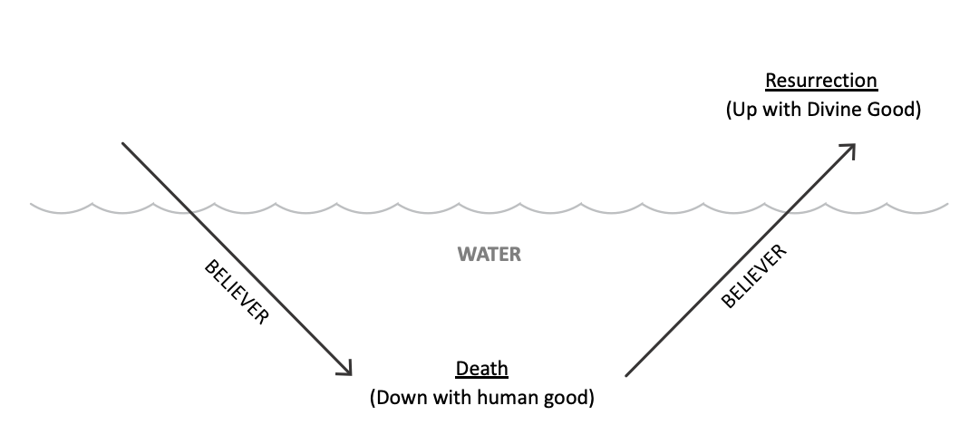

Human good has no place in the plan of God for a believer. Human good is never acceptable to God for salvation or spiritual growth. Obviously, the only kind of good we can perform when out of fellowship is human good. Human good is completely rejected by God as it is from the source of the old sin nature. Isaiah 64:6.

"For all of us have become like one who is unclean, And all our righteous deeds are like a filthy garment; And all of us wither like a leaf, And our iniquities, like the wind, take us away." (Isaiah 64:6, NASB)

The believer going into the water is identified with the water and they are saying in effect, “I am identified with Him in His death and in His death He rejected human good.” This is giving testimony to Retroactive Positional Truth, which is victory over human good.

The believer coming out of the water is then identified with the air which represents the resurrection of Jesus Christ and His session at the right hand of the Father. The believer gives testimony to Current Positional Truth - allowing His resurrection life to live through us. Each candidate for baptism should understand and believe in eternal security. Thus, coming into the air is a picture of eternal security coupled with positional truth.

Breathing represents performing divine good while in fellowship with God by the filling of the Holy Spirit. Human good and sin are produced while carnal or in a state of unconfessed sin where the believer’s soul is controlled by the old sin nature. Divine good can only be produced while filled with the Holy Spirit.

The believer being water baptized should understand that they are already identified with Christ in His death and therefore, positionally Christ has rejected human good. Believers are identified with Christ who is seated at the right hand of God the Father, therefore positionally believers cannot lose their salvation. They are new creatures in Christ. Therefore, believers should realize that in fellowship with Christ it is the filling of the Holy Spirit which is the basis of producing divine good. Divine good is also called the fruit of the Spirit and produces the character of Christ in each believer as they grow spiritually, the “renewing of your mind” in Romans 12:2.

"And do not be conformed to this world, but be transformed by the renewing of your mind, so that you may prove what the will of God is, that which is good and acceptable and perfect." (Romans 12:2, NASB)

From Current Positional Truth, we have the controlling ministry of the Holy Spirit which is the means of producing divine good. Divine good is always produced by the application of *epignosis* Bible doctrine and the functioning of the edification complex of the soul. The believer is saying, “I know now that the control of the Holy Spirit produces divine good. I am controlled by the Holy Spirit because 1 John 1:9 cleanses from all unrighteousness.

“If we confess our sins, He is faithful and righteous to forgive us our sins and to cleanse us from all unrighteousness.”  (1 John 1:9, NASB)

Baptism is the transition which indicates that you understand the issue in the Christian life is divine good vs. human good and that you are now ready to apply Retroactive Positional Truth. The way to understand water baptism is presented in the diagram below with three circles.

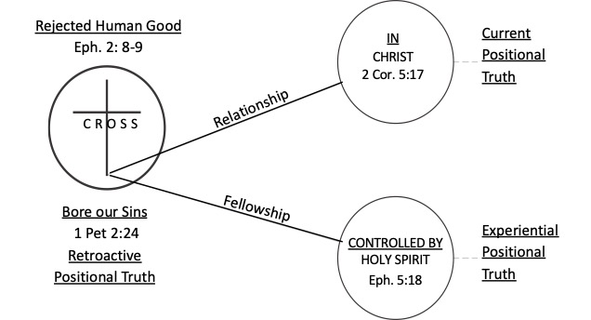

The circle of the Cross is identification with Christ in His deaths (spiritual and physical). It also represents Retroactive Positional Truth where Jesus Christ rejected human good on the Cross. The relationship circle shows identification with Christ, “In Christ,” as He is seated at the right hand of the Father. This is our Current Positional Truth as believers and is the basis of our eternal security. The fellowship circle illustrates Experiential Positional Truth, the place of the filling of the Holy Spirit (being in fellowship, being controlled by the Holy Spirit, being filled by Him, all synonymous terms) which produces divine good. Gal. 2:20.

““I have been crucified with Christ; and it is no longer I who live, but Christ lives in me; and the life which I now live in the flesh I live by faith in the Son of God, who loved me and gave Himself up for me.”  (Galatians 2:20, NASB)

“For by grace you have been saved through faith; and that not of yourselves, it is the gift of God; not as a result of works, so that no one may boast.”  (Ephesians 2:8-9, NASB)

“and He Himself bore our sins in His body on the cross, so that we might die to sin and live to righteousness; for by His wounds you were healed.”  (1 Peter 2:24, NASB)

“Therefore if anyone is in Christ, he is a new creature; the old things passed away; behold, new things have come.”  (2 Corinthians 5:17, NASB)

“And do not get drunk with wine, for that is dissipation, but be filled with the Spirit,”  (Ephesians 5:18, NASB)

**The Scope of Water Baptism**

Water baptism covers the entire scope of Bible doctrine from the point of salvation to the production of divine good and is a recognition of what God has provided for the individual in their Christian walk. The believer should understand that once you have believed in Christ, you are in union with Him, identified with Him in His death, and identified with Him in His resurrection. Therefore, you cannot lose your salvation. You should understand that human good has no place in your life because God has provided something better - the production of divine good. This comes only through the filling of the Holy Spirit.

Baptism is administered once, but one can always go back to the point of their baptism and realize the principals involved. Romans 6 is a chapter giving the relationship between positional truth and spirituality. Water baptism illustrates Positional Truth. The Lord’s Supper illustrates spirituality or fellowship. Consequently, water baptism illustrates Positional Truth, production of divine good and rejection of human good, eternal security as related to Positional Truth, the filling of the Holy Spirit, and that fellowship with God can only be achieved by naming or confessing sin to God the Father using 1 John 1:9.

"If we confess our sins, He is faithful and righteous to forgive us our sins and to cleanse us from all unrighteousness." (1 John 1:9, NASB)

Water baptism doesn’t save you or make you a better person. Water baptism is an illustrator of basic Bible doctrine. Water divides. The candidate is dead to human good. They are alive to divine good. They were baptized quickly after salvation in New Testament times because immediately after believing they were thoroughly instructed in the Bible doctrines which water baptism symbolizes. Once one understands these doctrines, there is nothing hindering a believer from being water baptized.

There are certain Scriptures that have often aroused questions regarding baptism. The accurate interpretation of each is presented briefly below.

In 1 Corinthians 15:29, “baptized for the dead” refers to believers who take the place of those who have died and gone on to their rewards. They are baptized “in place of those” who have gone on. There is no merit here. There is no authority in Scripture to baptize for the dead as the Mormons do.

"Otherwise, what will those do who are baptized for the dead? If the dead are not raised at all, why then are they baptized for them?" (1 Corinthians 15:29, NASB)

In Ephesians 4:5, “One Lord, one faith, one baptism” refers to Baptism of the Holy Spirit. In 1 Corinthians 12:13, salvation resulting in the Baptism of the Holy Spirit is in view here, not water baptism.

"one Lord, one faith, one baptism," (Ephesians 4:5, NASB)

"For by one Spirit we were all baptized into one body, whether Jews or Greeks, whether slaves or free, and we were all made to drink of one Spirit." (1 Corinthians 12:13, NASB)

In Hebrews 6:1-2, “instruction about washings” involved many baptisms and refers to the seven baptisms mentioned in the Word of God. Nowhere in the New Testament is someone “baptized” out of a bowl, urn, pan, bucket or even a tub. A river or body of water is used. Note that John the Baptist baptized in the Jordon River and Philip baptized in a pond at an oasis in the desert.

"Therefore leaving the elementary teaching about the Christ, let us press on to maturity, not laying again a foundation of repentance from dead works and of faith toward God, of instruction about washings and laying on of hands, and the resurrection of the dead and eternal judgment." (Hebrews 6:1-2, NASB)

In fact, the Scriptures indicate “much water” is the norm. By no stretch of the imagination is there much water when someone is sprinkled. John 3:23.

"John also was baptizing in Aenon near Salim, because there was much water there; and people were coming and were being baptized—" (John 3:23, NASB)

In Acts 8:38-39, the body of water was large enough for Philip and the eunuch for both to go down into the water. This is impossible under conditions of infant baptism or present day sprinkling.

"And he ordered the chariot to stop; and they both went down into the water, Philip as well as the eunuch, and he baptized him. When they came up out of the water, the Spirit of the Lord snatched Philip away; and the eunuch no longer saw him, but went on his way rejoicing." (Acts 8:38-39, NASB)

It is simple to see the analogy of the death, burial and resurrection of Christ in water baptism, but what analogy does sprinkling bring out? Generally the false forms of “baptism” are taught at a very early age and as such are believed, not on the basis of Scripture, but because mother believed in it, my church did this or as a child I was taught that this was biblical. Not one Scripture can be cited in defense of sprinkling or even infant baptism.

Is infant baptism Scriptural? No. Proponents in the light of no Scriptural proof have built this entire ritual on an analogy. Even as the Israelite child “of the covenant” was circumcised the eighth day, even so should the child today be baptized as an infant.

However the two bona fide rituals today (water baptism and the Lord’s Supper) are built on expression of positive volition. A child cannot exhibit positive volition at 8 days or 180 for that matter until they reach the age of accountability. Baptism is based upon the personal acceptance of Christ as Savior which results in the Baptism of the Spirit, and resultant Positional Truth. These doctrines would have no meaning to a child.

If a careful study of the term baptism is conducted, it is an ordinance carried out on the basis of understanding certain doctrines in the Word of God. Then where do such spurious doctrines come from? Easily answered, from false “systems” of theology which fill in various gaps with human teachings and viewpoints of men.

**Relationship of Three Gifts to Water Baptism**

Three gifts of grace are given to mankind on a volitional basis where man must choose. The gift of the woman to Adam is found in Genesis 2, Adam’s identification of the woman’s soul in Genesis 2:23-24, and visible identification where Adam was identified with the woman’s body by their consummation in marriage in Genesis 2:25.

"The man said, "This is now bone of my bones, And flesh of my flesh; She shall be called Woman, Because she was taken out of Man." For this reason a man shall leave his father and his mother, and be joined to his wife; and they shall become one flesh. And the man and his wife were both naked and were not ashamed." (Genesis 2:23-25, NASB)

The gift of salvation is an invisible identification by faith in the substitutionary spiritual death of the Lord Jesus Christ on the Cross. This completely saves the individual. There is also the visible identification in water baptism after salvation which pictures visibly what happened earlier invisibly. John 3:16; Acts 8:36-39.

""For God so loved the world, that He gave His only begotten Son, that whoever believes in Him shall not perish, but have eternal life." (John 3:16, NASB)

"As they went along the road they came to some water; and the eunuch said, "Look! Water! What prevents me from being baptized?" [And Philip said, "If you believe with all your heart, you may." And he answered and said, "I believe that Jesus Christ is the Son of God."] And he ordered the chariot to stop; and they both went down into the water, Philip as well as the eunuch, and he baptized him. When they came up out of the water, the Spirit of the Lord snatched Philip away; and the eunuch no longer saw him, but went on his way rejoicing." (Acts 8:36-39, NASB)

There is an invisible identification of the gift of Bible doctrine for the Christian way of life whereby the believer functions under the grace apparatus for perception, transfers Bible doctrine from the pages of the Bible to the right lobe of their soul. James 1:2-6.

"Consider it all joy, my brethren, when you encounter various trials, knowing that the testing of your faith produces endurance. And let endurance have its perfect result, so that you may be perfect and complete, lacking in nothing. But if any of you lacks wisdom, let him ask of God, who gives to all generously and without reproach, and it will be given to him. But he must ask in faith without any doubting, for the one who doubts is like the surf of the sea, driven and tossed by the wind." (James 1:2-6, NASB)

There is a visible identification which is the production of divine good in the spiritual life. James 2:14-26.

"You see that faith was working with his works, and as a result of the works, faith was perfected;" (James 2:22, NASB)

No one should be baptized until he or she understands clearly its significance. Ritual without reality is meaningless. Water baptism is the ritual or the picture of the real Baptism of the Holy Spirit. When you are baptized, you give testimony to the fact that Christianity is not a religion, but a personal relationship with Jesus Christ forever.